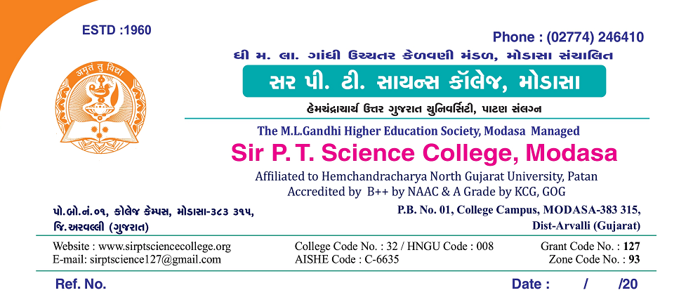**Register computer allotment**

|  |  |  |
| --- | --- | --- |
| No. | **Place** | **No. of Computers** |
| 1 | **Principle's Office** | 3 |
| 2 | **Admin office** | 4 |
| 3 | **Seminar Hall** | 1 |
| 4 | **Library --Desktop + All in one Lenovo (2)** | 7 |
| 5 | **Library Reading room** | 2 |
| 6 | **Theator Room 1 (Ground Floor)** | 1 |
| 7 | **Theator Room 2 (Ground Floor)** | 1 |
| 8 | **Room No 20 (First Floor)** | 1 |
| 9 | **Room No 21 (Second Floor)** | 1 |
| 10 | **Room No 23 (Second Floor)** | 1 |
| 11 | **Comp. Lab Room No 19** | 47 |
| 12 | **Dell Lab** | 26 |
| 13 | **Botnay Lab** | 2 |
| 14 | **Botnay Department** | 2 |
| 16 | **Physics Dept** | 1 |
| 17 | **Physics Computer Lab** | 6 |
| 18 | **Chemistry Dept.** | 2 |
| 19 | **Chemistryresearch Lab** | 1 |
| 20 | **Maths Department** | 1 |
| 21 | **Micro Departmet** | 2 |
| 22 | **SSIP** | 1 |
|  | **Total** | **113** |

